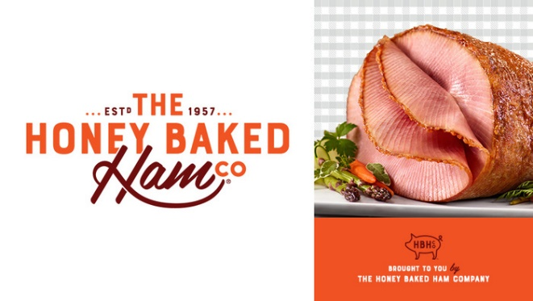

Honey Baked Ham Fundraiser

Support KSLA Literacy Projects
November 2021 thru June 2022

Ham, Turkey, Sides and Desserts are available at Honey Baked Ham Company Stores

Give as holiday gifts to family and friends or treat yourself and remove the stress of cooking!

20% of purchase goes to KSLA
Coupons from ads are accepted

Use the link below to purchase gift cards and e-cards:

https://honeybakedfundraising.com//fundraisers/Keystone_State_Literacy_Association_Chapt_Projects
(Link can also be found on the KSLA website)

